1. 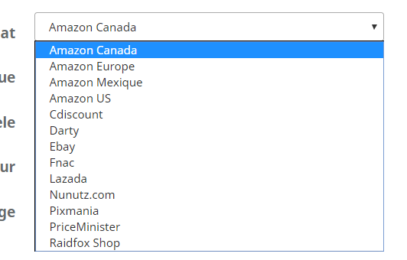

For Amazon/Cdiscount/PriceMinister/Lazada/Nunutz.com/Raidfox Shop

Need to send “FICHE DE RETOUR Price Minister.PDF”

1. For Darty/Macway/Fnac/Pixmania

Need to send “FICHE DE RETOUR SAV Fnac Darty Macway.pdf”

1. For Professionnal page, need to send “FICHE DE RETOUR SAV B2B.pdf”
2. Need to change the text “Succesfully …..” by :

French: « Demande de retour SAV acceptée. Vous recevrez notre procedure de retour à l’adresse mail indiquée d’ici quelques instants »

English : “Your return request has been accepted. You’ll receive our Return Form within a few minutes on the mail box that you have registered.”

